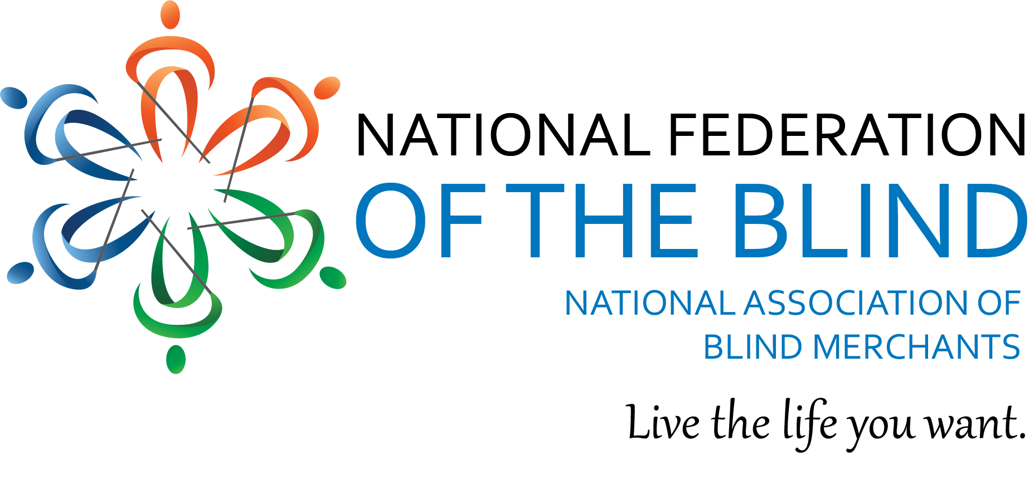

***BLAST FIELD OF DREAMS***

***AGENDA***

**Wednesday, June 14, 2023 – Renaissance Savery Hotel**

6:00 – 7:00 PM Networking Reception

**Thursday, June 15, 2023 – Iowa Department for the Blind**

9:00 – 9:15 AM “Welcome and Introductions”

Emily Wharton, Executive Director

Iowa Department for the Blind

and

Nicky Gacos, President

National Association of Blind Merchants

9:15 – 10:00 AM Individual State Reports

10:00 – 10:30 AM “The Self-Service Industry: Gaining Momentum”

Chris Ingram, Training Consultant

Canteloupe

and

Alex Buck, Regional Sales Director

Canteloupe

10:30 – 10:40 AM Break

10:40 – 10:55 AM “What’s New at Red Bull – Get Your Free Samples”

Kristina Allen, Regional Sales Manager

Red Bull North America

10:55 – 11:20 AM “Going Beyond the Priority”

Melba Taylor, Maryland Blind Entrepreneur

NABM Board Member

11:20 – 11:45 AM “SSDI: What You Need to Know” (Virtual)

Michael Dalto, SSA Consultant

National Association of Blind Merchants

11:45 AM Board Bus and Travel to USI Facility

8040 University Blvd. Clive, Iowa.

12:15 – 1:00 PM Working (Box) Lunch – Introductions to USI Team

1:00 – 2:00 PM Tour of USI Manufacturing Facility

2:00 - 2:15 PM Break

2:15 – 2:45 PM “Marketing Your Business by Telling Your Story”

Ashley N. Hubler, Chief Marketing Officer

2:45 – 3:05 PM “National Vending BEP Lease Program v. Traditional Equipment Leasing: A Viable Option for SLA’s?”

                                Samantha Hadden / Bob Daubach / Will Lynch

3:05 - 3:25 PM “USI Machine Accessibility & New Scan and Go Market”

Led by USI Engineering – Andres Martinez and Jim Chico

3:25 – 4:00 PM “Open Forum: What Are Your Vending Issues?”

Group Discussion

4:00 – 5:00 PM “Getting Personal: Hands on with the Vending Machines”   
USI Team.

5:00 PM              Adjourn: Buses Depart for Evening Activities

Wittern Farm

6:00 – 7:30 PM Good Old Fashioned Barbeque Dinner on the Farm

7:30 PM Buses Go Back to Downtown

**Friday, June 16, 2023 - Iowa Department for the Blind**

8:30 – 8:45 AM Opening Announcements

Welcome  
Matt Nemmers – Iowa BEP Administrator

8:45 – 9:15 AM “What’s Happening at RSA: A Virtual Presentation”

Jesse Hartle, RSA Randolph-Sheppard Program Specialist

9:15 – 9:30 AM “What’s New and Still the Same? The BEPLT Training”

Colleen Wunderlich, Chicago Lighthouse for the Blind

9:30 - 10:00 AM “New Strategies and Opportunities with DOD”

Terry Smith and Nicky Gacos

National Association of Blind Merchants

And

Doris Jones, Virginia Blind Entrepreneur and Military Veteran

10:00 – 10:10 AM Break

10:10 – 10:40 AM “A Q&A with a Panel of State Directors”

Moderated by Matt Nemmers, Program Administrator

Iowa Business Enterprises

10:40 – 11:10 AM “A Q&A with a Panel of Elected Committee Members”

Moderated by Michael Colbrunn, Chair

Minnesota Committee of Blind Vendors and NABM 2nd Vice President

11:10 – 11:25 AM “Chat GPT: How It Can Help Blind Entrepreneurs”

Enrique Meija, Instructor

Iowa Department for the Blind

11:25 – 11:30 AM Wrap Up

11:30 AM Adjourn

*The National Federation of the Blind knows that blindness is not the characteristic that defines you or your future. Every day we raise the expectations of blind people, because low expectations create obstacles between blind people and our dreams. You can live the life you want; blindness is not what holds you back.*

***Our Sponsors***

**Coca-Cola**

**PEPSICO**

**Sodexo**

**Blackstone Consulting, Inc.**

**FSIG**

**Southern Teaming Partners**

**RSA Management Group**

**VISTAR**

**U-Select-It**

**Brown, Goldstein, and Levy**

**Tyler Technologies**

**Anderson Food Services**

**Red Bull**