**Grand Canyon Animal Trail Game!**

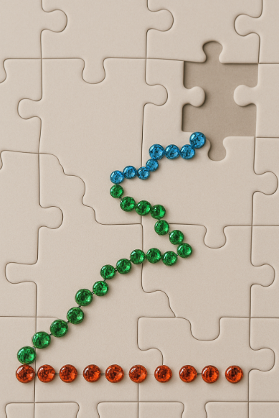

**Game SUPPLIES**

* 24 Piece Puzzle mixed with a rhinestone or sticker trail
* Scented Marker

**🧩 How to Play: Grand Canyon Animal Trail Puzzle Game**

1. Answer 12 fun animal and canyon-themed questions.
2. Each correct answer earns 1 rhinestone puzzle piece.
3. Choose between 2 answer options for each question.
4. Add 2-pieces to your puzzle to build a sparkling Grand Canyon trail.
5. Complete all 24 pieces to finish the puzzle and become a Junior Canyon Explorer!

**Answer:**

* **A** = 1 Finger
* **B** = 2 Fingers

***Round of Questions***

1. What bird has huge wings and can fly very high?  
   A) Penguin  
   B) California Condor (correct answer)  
   🧩 Piece 1
2. Which animal makes a rattling sound with its tail?  
   A) Rattlesnake (correct answer)  
   B) Bunny  
   🧩 Piece 2
3. What river carved the Grand Canyon?  
   A) Colorado River (correct answer)  
   B) Mississippi River  
   🧩 Piece 3
4. Which animal climbs rocky cliffs?  
   A) Bighorn Sheep (correct answer)  
   B) Dolphin  
   🧩 Piece 4
5. Which tiny animal hops and lives in the desert?  
   A) Kangaroo Rat (correct answer)  
   B) Elephant  
   🧩 Piece 5
6. What animal hoots at night?  
   A) Owl (correct answer)  
   B) Duck  
   🧩 Piece 6
7. What animal howls like a dog?  
   A) Coyote (correct answer)  
   B) Fish  
   🧩 Piece 7
8. Which bird dives fast from high in the sky?  
   A) Falcon (correct answer)  
   B) Turkey  
   🧩 Piece 8
9. Which animal is small, green, and croaks?  
   A) Canyon Tree Frog (correct answer)  
   B) Bear  
   🧩 Piece 9
10. Which bug builds mounds and works with friends?  
    A) Ant (correct answer)  
    B) Butterfly  
    🧩 Piece 10
11. What animal has a black mask and likes to wash food?  
    A) Raccoon (correct answer)  
    B) Cow  
    🧩 Piece 11
12. What is the Grand Canyon?  
    A) A giant crack in the Earth (correct answer)  
    B) A swimming pool  
    🧩 Piece 12