Week 3

Mystery Clay

*What’s Hiding Inside!*

Interactive Games and Mystery Adventure

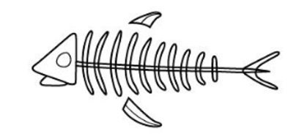

We’re exploring ancient secrets hidden in clay! Each paper bag holds a surprise from the past. Use your hands to uncover what’s hiding inside.

**HOW TO PLAY**

**Step 1: Explore the Mystery Bag**

* Reach into the paper bag!
* Explore the object with your fingers.
* Say what you feel: *“Is it bumpy? Smooth? Spiky?”*
* Guess what you think it is. *(No wrong answers!)*

**Step 2: Need something new to explore - Make a Clay Fossil**

* Press clay firmly all over one of the items found in the bag or find a fossil impression on the fossil tactile map.
* Peel it off and explore the fossil impression.
* How does it feel compared to the object?

**Step 3: The Fossil Reveal!**

🌀 **Keep Discovering**

Smooth out your clay—ready for the next mystery?

Keep imagining, exploring, and fossil-hunting!

**Don’t forget your hands are your best tools, and your guesses make you a great explorer!**

