**The Great Egg Carton Boat Float-Off Challenge**

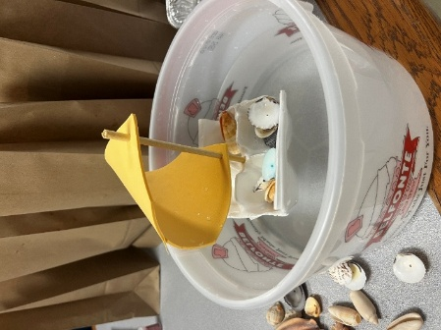

*“Ahoy, Boat Builders! Welcome to today’s STEM Challenge: You’re going to build a boat, test your design, and see how many tiny treasures it can carry before it sinks!”*

**Adventure 1: BUILD YOUR BOAT**

**Gather your Supplies:**

* Half an egg carton (6 cups)
* One wooden dowel or straw
* One foam sheet or piece of paper
* Some tape or hole punch
* And some tiny treasures: coins, buttons, shells, LEGOs—anything small!

**Time to Build:**

**Step One:** Take your foam sheet or paper and poke two holes—one on each end. Now slide the dowel or straw through both holes. *“You’ve just made your sail!”*

**Step Two:** Stick the sail into the middle of your egg carton. Right into one of the cups. *“Now you’ve got a real boat!”*

**Step Three:** Carefully float your boat in a tub or bowl of water. *“Don’t worry—if you don’t have water, you can still play by guessing and testing later.”*

**ARE YOU READY FOR EXTRA FUN?** “Give your boat a name! I’m calling mine the *SS STEM Supreme!* What’s yours?

### **Adventure 2: Game Time – The Float-Off Challenge!**

### **Can you Guess??? “How many treasures can your boat hold before it SINKS?!**”

* When I say go, everyone will place **one** treasure inside your boat and start counting, 1 treasure, 2 treasure, 3 treasure, until the boat starts tipping!
* As soon as your boat tips over or sinks, yell out, **MAYDAY!**
* Then count your treasures.

**Bonus Challenge: Can you make your boat float better?** Spread out your treasures OR try smaller items. Move your sail to a different cup OR add waves (gently blow on the water).

**Everyone, together, shout, Bon voyage!**