**Teepee Tales Game!**

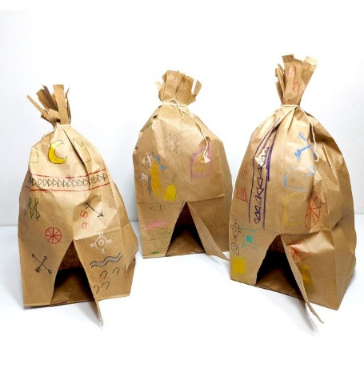

*“Build a story right on your paper bag teepee!”*

**You’ll Need:**

* 1 paper lunch bag (pre-cut)
* A piece of string or pipe cleaner
* Stickers
* A crayon [Option Triangle Shape]
* Tactile game dice

**Set Up Your Teepee:**

* Stand up your paper bag
* Twist the top and tie it with a string or pipe cleaner!
* Place your teepee in front of you—This is where your story will come to life!

**How to Play the Game:**

|  |  |
| --- | --- |
|  |  |

Take turns rolling your dice. Each number tells you what to draw or stick on your teepee!

1. Draw a mountain
2. Add sun sticker
3. Add an animal or add a butterfly sticker
4. Add a tree or flower (draw or sticker)
5. Add a special shape—like a heart or swirl
6. Make something magical—your choice!

**Tell Your Story!**

After a few rounds, show off your teepee and tell a mini story about who lives inside and what the symbols on the outside mean!

**Accessibility Tips!**

1. Triangle Shape Crayons – Stays in place, Waxy easy to feel.
2. Dice - Raised Dots
3. Scented or tactile Stickers.
4. Pipe cleaner – Easy to twist.