**FEED THE ALLIGATOR! – Catapult Game Challenge**   
*It’s a bug-flinging, bell-launching, alligator-feeding frenzy!*

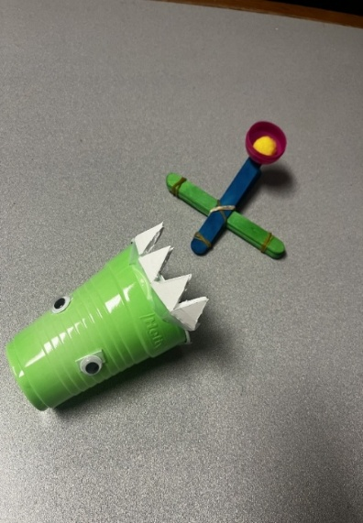

**Can YOU feed the hungry alligator before time runs out? Let’s find out!**

**Supplies You'll Need:**

* Catapult supplies kit
* One extra rubber band (outside the kit)
* 4 jingly bells (yum!)
* 1 colorful plastic cup (a.k.a. the alligator's mouth)
* 8 foam board “teeth”
* 2 googly eyes (no gator is complete without ‘em!)
* Tape (not included, but super helpful!)

**Step 1: Build Your Bug-Launching Catapult!**

Open up your catapult kit and follow the directions inside. You’ll be creating your very own bug (bell)-flinging launcher!

**Quick Build Recap:**

1. Rubber band four sticks together at both ends.
2. Rubber band the remaining two sticks on one end only.
3. Slide the big bundle into the open end of the small one (like a sandwich).
4. Rubber band the two groups together in an “X” shape.
5. Stick the mini plastic bowl to the top of your catapult using the sticky square.

*Now you're armed with a bug launcher!*

**Step 2: Create Your Chompy Alligator Cup!**

Let’s give our hungry gator some *serious* bite:

1. Lay a sticky-side-up piece of tape on the table.
2. Place 4 foam teeth on it and wrap them around one side of the cup’s rim.
3. Repeat on the other side = your alligator now has TEETH!
4. Roll up two tiny tape balls (sticky side out), stick them to the googly eyes, then attach the eyes to the side of the cup (just under the teeth).

*You now have a toothy, wide-mouthed alligator waiting for dinner!*

**ROAR-SOME BONUS:**  
Make it silly! Give your gator a name like “Snappy,” “Chompers,” or “Captain Cranky-Teeth!”

**GAME TIME! – Feed the Gator**

* How many bells can you feed the gator in 60 seconds?
* 1 bell in the cup = 1 point. Most points wins!
* Move the gator farther after each round!

**Accessibility Tips!**

1. Decorate the gator with puffy paint, braille stickers, or scented markers.
2. Add bumpy textures or tactile tape to help with aiming.
3. Put the gator cup in a tray or box to catch missed bells.
4. Make a fun sound when a bell lands — shout “CHOMP!”