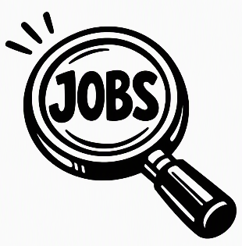
IDB October is for Opportunity –
National Disability Employment Awareness Month

Are you a blind or low-vision student who is interested in knowing more about the world of work?
Join us for 3 exciting online workshops in October:
Thursdays-4:00 PM Central
- October 8, with Sarah Coleman, Board Chair of the Iowa Commission for the Blind
- October 15, with Erin Lauridsen, blind Accessibility strategist, CVS Health
- October 22, with John Fritz, blind farmer and entrepreneur
Zoom: ACE Iowa Link
- Featuring conversations and interviews with successful blind guests
Ready to sign up? Reach out to your VR counselors-
Contact: Gloria Graves at IDB: Gloria.Graves@blind.state.ia.us
Lisa Ortner - Lisa.Ortner@blind.state.ia.us
Sarah Baebler – Sarah.Baebler@blind.state.ia.us
This Pre-Employment Transition training is sponsored by: Iowa Department for the Blind IDB and Powered by David DeNotaris of Sky’s the Limit Communications LLC, and Eileen Rivera Ley of Blind Savvy USA.

